Lecture 4.
Characterization of human embryonic organogenesis.
Human embryo at 5, 6, 7, 8 weeks.
Conception about the critical periods and embryotrop factors.
Histology as biological and medical science.
Tissues – definition, classification.
Epithelial tissues: histogenesis, classification, morpho-functional features.
Covering epithelium.
Glandular epithelium.
The mechanism and periods of secretion.

The embryonic period, or period of organogenesis, occurs from the third to the eighth weeks of development and is the time when each of the three germ layers, ectoderm, mesoderm, and endoderm, gives rise to a number of specific tissues and organs. By the end of the embryonic period, the main organ systems have been estabhshed, rendering the major features of the external body form recognizable by the end of the second month.
Derivatives Of The Ectodermal Germ Layer. At the beginning of the third week of development, the ectodermal germ layer has the shape of a disc that is broader in the cephalic than in the caudal region. Appearance of the notochord and prechordal mesoderm induces the overlying ectoderm to thicken and form the neural plate. Cells of the pнate make up the neuroectoderm, and their induction represents the initial event in the process of neurulation.
Molecular Reguiation of Neural Induction. Upregulation of fibroblast growth factor (FGF) signaling together with inhibition of the activity of bone morphogenetic protein 4 (BMP4), a transforming growth factor-j3 (TGF-P) family member responsible for ventralizing ectoderm and mesoderm, causes induction of the neural plate. FGF signaling probably promotes a neural pathway by an unknown mechanism while it represses BMP transcription and upregulates expression of CHORDIN and NOGGIN, which inhibit BMP activity. In the presence of BMP4, which permeates the mesoderm and ectoderm of the gastrulating embryo, ectoderm is induced to form epidermis, and mesoderm forms intermediate and lateral plate mesoderm. If ectoderm is protected from exposure to BMPs, its “default State” is to become neural tissue. Secretion of three other molecules, noggin, chordin, and follistatin, inactivates BMP. These three proteins are present in the organizer (primitive node), notochord, and prechordal mesoderm. They neuralize ectoderm by inhibiting BMP and cause mesoderm to become notochord and paraxial mesoderm (dorsalizes mesoderm); however, these neural inducers induce only forebrain and midbrain types of tissues. Induction of caudal neural plate structures (hindbrain and spinal cord) depends on two secreted proteins, W NT3a and FGF. In addition, retinуle acid (RA) appears to play a role in organizing the cranial-to-caudal axis because it can cause respecification of cranial segments into more caudal ones by regulating expression of homeobox genes .
Neurulation. Neurulation is the process whereby the neural plate forms the neural tube. One of the key events in this process is lengthening of the neural plate and body axis by the phenomenon of convergent extensiуn, whereby there is a lateral to medial movement of cells in the plaсe of the ectoderm and mesoderm. The process is regulated by signaling through the planar cell polarity pathway and is essential for neural tube development. As the neural plate lengthens, its lateral edges elevate to form neural folds, and the depressed midregion forms the neural groove. Gradually, the neural folds approach each other in the midline, where they fuse. Fusion begins in the cervical region (fifth somite) and proceeds cranially and caudally. As a result, the neural tube is formed. Until fusion is complete, the cephalic and caudal ends of the neural tube communicate with the amniotic cavity by way of the anterior (cranial) and posterior (caudal) neuropores respectively. Closure of the cranial neuropore occurs at approximately day 25 (18- to 20-somite stage), whereas the posterior neuropore closes at day 28 (25-somite stage) . Neurulation is then complete, and the central nervous system is represented by a closed tubular structure with a narrow caudal portion, the spinal cord, and a much broader cephalic portion characterized by a number of dilations, the brain vesicles.
Neural Crest Cells. As the neural folds elevate and fuse, cells at the lateral border or crest of the neuroectoderm begin to dissociate from their neighbors. This cell population, the neural crest , will undergo an epithelial-to-mesenchymal transition as it leaves the neuroectoderm by active migration and displacement to enter the underlying mesoderm. (Mesoderm refers to cells derived from the epiblast and extraembryonic tissues. Mesenchyme refers to loosely organized embryonic connective tissue regardless of origin.) Crest cells from the trunk region leave the neuroectoderm after closure of the neural tube and migrate along one of two pathways: (1) a dorsal pathway through the dermis, where they will enter the ectoderm through holes in the basal lamina to form melanocytes in the skin and hair follicles, and (2) a ventral pathway through the anterior half of each somite to become sensory ganglia, sympathetic and enteric neurons, Schwann cells, and cells of the adrenal medulla. Neural crest cells also form and migrate from cranial neural folds, leaving the neural tube before closure in this region. These cells contribute to the craniofacial skeleton as well as neurons for cranial ganglia, glial cells, melanocytes, and other cell types . Neural crest cells are so fundamentally important and contribute to so many organs and tissues that they are sometimes referred to as the fourth germ layer. Evolutionarily, these cells appeared at the dawn of vertebrate development and expanded this group extensively by perfecting a predatory lifestyle.
Molecular Regulatlon of Neural Crest Induction. Induction of neural crest cells requires an interaction at the junctional border of the neural plate and surface ectoderm (epidermis). Intermediate concentrations of BMPs are established at this boundary compared to neural plate cells that are exposed to very low levels of BMPs and surface ectoderm cells that are exposed to very high levels. The proteins noggin and chordin regulate these concentrations by acting as BMP inhibitors. The intermediate concentrations of BMPs, together with FGF and WNT proteins, induce PAX3 and other transcription factors that “specify” the neural plate border . In turn, these transcription factors induce a second wave of transcription factors, including SNAIL and F0XD3, which specify cells as neural crest, and SLUG, which promotes crest cell migration from the neuroectoderm. Thus, the fate of the entire ectodermal germ layer depends on BMP concentrations: High levels induce epidermis formation; intermediate levels, at the border of the neural plate and surface ectoderm, induce the neural crest; and very low concentrations cause formation of neural ectoderm. BMPs, other members of the TGF-(3 family, and FGFs regulate neural crest cell migration, proliferation, and differentiation, and abnormal concentrations of these proteins have been associated with neural crest defects in the craniofacial region of laboratory animals. By the time the neural tube is closed, two bilateral ectodermal thickenings, the otic placodes and the lens placodes, become visible in the cephalic region of the embryo. During further development, the otic placodes invaginate and form the otic vesicles, which will develop inte structures needed for hearing and maintenance of equilibrium . At approximately the same time, the lens placodes appear. These placodes also invaginate and, during the fifth week, form the lenses of the eyes . In general terms, the ectodermal germ layer gives rise to organs and structures that maintain contact with the outside world:
■ The central nervous system
■ The peripheral nervous system
■ The sensory epithelium of the ear, nose, and eye
■ The epidermis, including the hair and nails
In addition, it gives rise to the following:
■ The subcutaneous glands
■ The mammary glands
■ The pituitary gland
■ Enamel of the teeth
Initially, cells of the mesodermal germ layer form athin sheet of loosely woven tissue on each side of the midline . By approximately the 17th day, however, cells ciуse to the midline proliferate and form a thickened plate of tissue known as paraxial mesoderm . More laterally, the mesoderm layer remains thin and is known as the lateral plate. With the appearance and coalescence of intercellular cavities in the lateral plate, this tissue is divided into two layers :
■ A layer continuous with mesoderm covering the amnion, known as the somatic or parietal mesoderm layer
■ A layer continuous with mesoderm covering the yolk sac, known as the splanchnic or visceral mesoderm layer . Together, these layers line a newly formed cavity, the intraembryonic cavity, which is continuous with the extraembryonic cavity on each side of the embryo. Intermediate mesoderm connects paraxial and lateral plate mesoderm .
Paraxial Mesoderm. By the beginning of the third week, paraxial mesoderm begins to be organized into segments. These segments, known as somitomeres, first appear in the cephalic regiуn of the embryo, and their formation proceeds cephalocaudally. Each somitomere consists of mesodermal cells arranged in concentric whorls around the center of the unit. In the head region, somitomeres form in association with segmentation of the neural plate into neuromeres and contribute to mesenchyme in the head. From the occipital regiуn caudally, somitomeres further organize into somites. The first pair of somites arises in the occipital regiуn of the embryo at approximately the 20th day of development. From here, new somites appear in craniocaudal sequence at a rate of approximately three pairs per day until, at the end of the fifLh week, 42 to 44 pairs are present. There are 4 occipital, 8 cervical, 12 thoracic, 5 lumbar, 5 sacral, and 8 to 10 coccygeal pairs. The first occipital and the last five to seven coccygeal somites later disappear, while the remaining somites form the axial skeleton. Because somites appear with a specified periodicity, the age of an embryo can be accurately determined during this early time period by counting somites.
Molecular Regulatlon of Somite Formation. Formation of segmented somites from unsegmented presomitic (paraxial) mesoderm depends on a segmentation dock established by cyclic expression of a number of genes. The cyclic genes include members of the NOTCH and WNT signaling pathways that are expressed in an oscillating pattern in presomitic mesoderm. Thus, Notch protein accumulates in
presomitic mesoderm destinad to form the next somite and then decreases as that somite is established. The increase in Notch protein activates other segment-patterning genes that establish the
somite. Boundaries for each somite are regulated by RA and a combination of FGF8 and WNT3a. RA is expressed at high concentrations cranially and decreases in concentration caudally, whereas the combination of FGF8 and WNT3a proteins is expressed at higher concentrations caudally and lower ones cranially. These overlapping expression gradients contiol the segmentation dock and activity of the NOTCH pathway.
Somite Differentiation. When somites first form from presomitic mesoderm, they exist as a ball of mesoderm (fibroblastlike) cells. These cells then undergo a process of epithelization and arrange themselves in a donut shape around a small lumen. By the beginning of the fourth week, cells in the ventral and medial walls of the somite lose their epithelial characteristics, become mesenchymal (fibroblast-like) again, and shift their position to surround the neural tube and notochord. Collectively, these cells form the sclerotome that will differentiate into the vertebrae and ribs . Cells at the dorsomedial and ventrolateral edges of the upper region of the somite form precursors for muscle cells, whereas cells between these two groups form the dermatome . Cells from both muscle precursor groups become mesenchymal again and migrate beneath the dermatome to create the dermomyotome . In addition, cells from the ventrolateral edge migrate into the parietal layer of lateral plate mesoderm to form most of the musculature for the body wall (external and internal oblique and transversus abdominis muscles) and most of the imb muscles . Cells in the dermomyotome ultimately form dermis for the skin of the back and muscles for the back, body wall (intercostal muscles), and some limb muscles . Each myotome and dermatome retains its innervation from its segment of origin, no matter where the cells migrate. Henee, each somite forms its own sclerotome (the tendуn cartilage and bone component), its own myotome (providing the segmental muscle component), and its own dermatome, which forms the dermis of the back. Each myotome and dermatome also has its own segmental nerve component.
Molecular Regulatlon of Somite Differentiation. Signals for somite differentiation arise from surrounding structures, including the notochord, neural tube, epidermis, and lateral plate mesoderm . The secreted protein products of the NOGGIN genes and sonic hedgehog (SHH), produced by the notochord and floor pнate of the neural tube, induce the ventromedial portion of the somite to become sclerotome. Once induced, sclerotome cells express the transcription factor PAXl, which initiates the cascade of cartilage and bone-forming genes for vertebral formation. Expression of PAX3, regulated by WNT proteins from the dorsal neural tube, marks the dermomyotome regiуn of the somite. WNT proteins from the dorsal neural tube also target the dorsomedial portion of the somite, causing it to initiate expression of the muscle-specific gene MYF5 and to form primaxial muscle precursors. Interplay between the inhibiting protein BMP4 (and probably
FGFs) from the lateral plate mesoderm and activating WNT products from the epidermis direct the dorsolateral portion of the somite to express another muscle-specific gene, MYOD, and to form primaxial and abaxial muscle precursors. The midportion of the dorsal epithelium of the somite is directed by neurotrophin 3 (NT-3), secreted by the dorsal region of the neural tube, to form dermis. Intermediate Mesoderm. Intermediate mesoderm, which temporarily connects paraxial mesoderm with the lateral plate , differentiates into urogenital structures. In cervical and upper thoracic regions, it forms segmental cell clusters (ftiture nephrotomes), whereas more caudally, it forms an unsegmented mass of tissue, the nephrogenic cord. Excretory units of the urinary system and the gonads develop from this partly segmented, partly unsegmented intermediate mesoderm .
Lateral Plate Mesoderm. Lateral plate mesoderm splits into parietal (somatic) and visceral (splanchnic) layers, which line the intraembryonic cavity and surround the organs, respectively . Mesoderm from the parietal layer, together with overlying ectoderm, forms the lateral body wall folds. These folds, together with the head (cephalic) and tail (caudal) folds, ciуse the ventral body wall. The parietal layer of lateral plate mesoderm then forms the dermis of the skin in the body wall and limbs, the bones and connective tissue of the limbs, and the sternum. In addition, sclerotome and muscle precursor cells that migrate into the parietal layer of lateral pнate mesoderm form the costal cartilages, limb muscles, and most of the body wall muscles . The visceral layer of lateral pнate mesoderm, together with embryonic endoderm, forms the wall of the gut tube. Mesoderm cells of the parietal layer surrounding the intraembryonic cavity form thin membranes, the mesothelial membranes, or serous membranes, which will line the peritoneal, pleural, and pericardial cavities and secrete serous fluid. Mesoderm cells of the visceral layer form a thin serous membrane around each organ .
Derivatives Of The Endodermal Germ Layer. The gastrointestinal tract is the main organ system derived from the endodermal germ layer. This germ layer covers the ventral surface of the embryo and forms the roof of the yolk sac . With development and growth of the brain vesicles, however, the embryonic disc begins to bulge into the amniotic cavity. Lengthening of the neural tube now causes the embryo to curve into the fetal position as the head and tail regions (folds) move ventrally . Simultaneously, two lateral body wall folds form and also move ventrally to ciуse the ventral body . As the head and tail and two lateral folds move ventrally, they pull the amnion down with them, such that the embryo lies within the amniotic cavity . The ventral body wall closes completely except for the umbilical region where the connecting stalk and yolk sac duct remain attached . Failure of the lateral body folds to close the body wall results in ventral body wall defects . As a result of cephalocaudal growth and closure of the lateral body wall folds, a continuously larger portion of the endodermal germ layer is incorporated into the body of the embryo to form the gut tube. The tube is divided into three regions: the foregut, midgut, and hindgut. The midgut communicates with the yolk sac by way of a broad stalk, the vitelline (yolk sac) duct . This duct is wide initially, but with further growth of the embryo, it becomes narrow and much longer . At its cephalic end, the foregut is temporarily bounded by an ectodermal-endoderma membrane called the oropharyngeal membrane . This membrane separates the stomodeum, the primitive oral cavity derived from ectoderm, from the pharynx, a part of the foregut derived from endoderm. In the fourth week, the oropharyngeal membrane ruptures, establishing an open connection between the oral cavity and the primitive gut. The hindgut also terminales temporarily at an ectodermal-endodermal membrane, the cloacal membrane . This membrane separates the upper part of the anal canal, derived from endoderm, from the lower part, called the proctodeum, which is formed by an invaginating pit lined by ectoderm. The membrane breaks down in the seventh week to create the opening for the anus. Another important result of cephalocaudal growth and lateral folding is partial incorporation of the allantois into the body of the embryo, where it forms the cloaca . The distal portion of the allantois remains in the connecting stalk. By the fifth week, the yolk sac duct, allantois, and umbilical vessels are restricted to the umbilical region . The role of the yolk sac is not clear. It may function as a nutritive organ during the earliest stages of development prior to the establishment of blood vessels. It also contributes some of the first blood cells, although this role is very transitory. One of its main functions is to house germ cells that reside in its posterior wall and later migrate to the gonads to form eggs and sperm . Henee, the endodermal germ layer initially forms the epithelial lining of the primitive gut and the intraembryonic portions of the allantois and vitelline duct . During further development, endoderm gives rise to the following:
■ The epithelial lining of the respiratory tract
■ The parenchyma of the thyroid, parathyroids, liver, and pancreas
■ The reticular stroma of the tonsils and the thymus
■ The epithelial lining of the urinary bladder and the urethra
■ The epithelial lining of the tympanic cavity and auditory tube
Cells of multicellular organisms congregate to form structural and functional associations, known as tissues. Each of the four basic tissues of the body-epithelium, connective tissue, muscle, and nervous tissue-possesses specific, defined characteristics, which are detailed in subsequent chapters. However, all tissues are composed of cells and an extracellular matrix (ECM), a complex of nonliving macromolecules manufactured by the cells and exported by them into the extracellular space. Some tissues, such as epithelium, form sheets of cells with only a scant amount of ECM. At the opposite extreme is connective tissue, composed mostly of ECM with a limited number of cells scattered throughout the matrix. Cells maintain their associations with the ECM by forming specialized junctions that hold them to the surrounding macromolecules. This chapter explores the nature of the ECM not only as it relates to the tissues that house it but also as it relates to the cells contained within it. Although it was initially believed that the ECM merely forms the skeletal elements of the tissue in which it resides, it is now known that it may also:
- Modify the morphology and functions of cells
- Modulate the survival of cells
- Influence the development of cells
- Regulate the migration of cells
- Direct mitotic activity of cells
- Form junctional associations with cells
The ECM of the connective tissue proper, the most common connective tissue of the body, is composed of a hydrated gel-like ground substance with fibers embedded in it. Ground substance resists forces of compression, and fibers withstand tensile forces. The water of hydration permits the rapid exchange of nutrients and waste products carried by the extracellular fluid as it percolates through the ground substance.
BASEMENT MEMBRANE. The basement membrane seen with light microscopy is shown by electron microscopy to be composed of the basal lamina and lamina reticularis. The interface between epithelium and connective tissue is occupied by a narrow, acellular region-the basement membrane-which is well stained by the PAS reaction and by other histological stains that detect GAGs. A structure similar to the basement membrane, the external lamina, surrounds smooth and skeletal muscle cells, adipocytes, and Schwann cells. Electron microscopy shows that the basement membrane has two constituents: the basal lamina, elaborated by epithelial cells, and the lamina reticularis, manufactured by cells of the connective tissue. The epithelial sheath is bound to the underlying connective tissue by these resilient acellular interfaces, the basal lamina and lamina reticularis. Basal Lamina. The basal lamina manufactured by the epithelium is composed of the lamina lucida and the lamina densa. Electron micrographs of the basal lamina display its two regions: the lamina lucida, a 50-nm-thick electron-lucent region just beneath the epithelium, and the lamina densa, a 50-nm-thick electron-dense region . The lamina lucida consists mainly of the extracellular glycoproteins laminin and entactin, as well as of integrins and dystroglycans, transmembrane laminin receptors (both discussed later), that project from the epithelial cell membrane into the basal lamina. In rapidly frozen tissues, the lamina lucida is frequently absent, suggesting that it may be an artifact of fixation and that the lamina densa may be closer to the integrins and dystroglycans of the basal cell membrane than previously believed. The lamina densa comprises a meshwork of type IV collagen, which is coated on both the lamina lucida and lamina reticularis sides by the proteoglycan perlacan. The heparan sulfate side chains projecting from the protein core of perlacan form a polyanion. The lamina reticularis aspect of the lamina densa also possesses fibronectin. Laminin has domains that bind to type IV collagen, heparan sulfate, and the integrins and dystroglycans of the epithelial basal cell membrane, thus anchoring the epithelial cell to the basal lamina. The basal lamina appears to be well anchored to the reticular lamina by several substances, including fibronectin, anchoring fibrils (type VII collagen), and microfibrils (fibrillin), all elaborated by fibroblasts of connective tissue . The basal lamina functions both as a molecular filter and as a flexible, firm support for the overlying epithelium. The filtering aspect is due not only to the type IV collagen, whose interwoven meshwork forms a physical filter of specific pore size, but also to the negative charges of its heparan sulfate constituent, which preferentially restricts the passage of negatively charged molecules. Additional functions of the basal lamina include facilitating mitotic activity and cell differentiation, modulating cellular metabolism, assisting in the establishment of cell polarity, playing a role in the modification of the arrangement of the integral proteins localized in the basal cell membrane, and acting as a path for cellular migration, as in re-epithelialization during wound repair or in the reestablishment of myoneural junctions during regeneration of motor nerves. Integrins and dystroglycans are transmembrane glycoproteins that act as laminin receptors as well as organizers of basal lamina assembly.
Integrins are transmembrane proteins that are similar to cell membrane receptors in that they form bonds with ligands. However, unlike those of receptors, their cytoplasmic regions are linked to the cytoskeleton, and their ligands are not signaling molecules but structural members of the ECM such as collagen, laminin, and fibronectin. Moreover, the association between an integrin and its ligand is much weaker than that between a receptor and its ligand. Integrins are much more numerous than receptors, thus compensating for the bond weakness and also permitting the migration of cells along a surface of the ECM. Integrins are heterodimers (∼250,000 Da) composed of α and β glycoprotein chains whose carboxyl ends are linked to talin and α-actinin of the cytoskeleton. Their amino ends possess binding sites for macromolecules of the ECM. Because integrins link the cytoskeleton to the ECM, they are also called transmembrane linkers. The α-chain of the integrin molecule binds Ca²⁺ or Mg²⁺, divalent cations necessary for the maintenance of proper binding with the ligand. Many integrins differ in their ligand specificity, cellular distribution, and function. Some are commonly referred to as receptors for their ligands (e.g., laminin receptor, fibronectin receptor). Cells can modulate the affinity of their receptor for its ligand by regulating the availability of divalent cations, modifying the conformation of the integrin, or otherwise altering the integrin's affinity for the ligand. In this manner, cells are not locked into a particular position once their integrins bind to the macromolecules of the ECM but can release their integrin-ligand bonds and move away from that particular location. In addition to their roles in adhesion, integrins function in transducing biochemical signals into intracellular events by activating second messenger system cascades. The versatility of integrins in biochemical transduction is evidenced by their ability to stimulate diverse signaling pathways, including mitogen-activated protein kinase, protein kinase C, and phosphoinositide pathways that lead to activation of the cell cycle, cell differentiation, cytoskeletal reorganization, regulation of gene expression, and even programmed cell death via apoptosis. Frequently, integrins have to be activated by focal adhesion kinase, a protein tyrosine kinase; otherwise, they cannot initiate their signaling functions.
Dystroglycans are glycoproteins that are also composed of two subunits, a transmembrane β-dystroglycan and an extracellular α-dystroglycan. The α-dystroglycan binds to the laminin of the basal lamina but at different sites than does the integrin molecule. The intracellular moiety of the β-dystroglycan binds to the actin-binding protein dystrophin, which, in turn, binds to α-actinin of the cytoskeleton. Dystroglycans and integrins have significant roles in the assembly of basal laminae because embryos lacking either or both of these glycoproteins are unable to form normal basal laminae. The approximately 200 distinctly different types of cells composing the human body are arranged and cooperatively organized into four basic tissues. Groups of these tissues are assembled in various organizational and functional arrangements into organs, which carry out functions of the body. The four basic tissue types are epithelium, connective tissue, muscle, and nervous tissue. Epithelial tissue is present in two forms: (1) as sheets of contiguous cells (epithelia) that cover the body on its external surface and line the body on its internal surface, and (2) as glands, which originate from invaginated epithelial cells. Epithelia are derived from all three embryonic germ layers, although most of the epithelia are derived from ectoderm and endoderm. The ectoderm gives rise to the oral and nasal mucosae, cornea, epidermis of the skin, and glands of the skin and the mammary glands. The liver, the pancreas, and the lining of the respiratory and gastrointestinal tract are derived from the endoderm. The uriniferous tubules of the kidney, the lining of the male and female reproductive systems, the endothelial lining of the circulatory system, and the mesothelium of the body cavities develop from the mesodermal germ layer. Epithelial tissues have numerous functions:
- Protection of underlying tissues of the body from abrasion and injury
- Transcellular transport of molecules across epithelial layers
- Secretion of mucus, hormones, enzymes, and so forth, from various glands
- Absorption of material from a lumen (e.g., intestinal tract or certain kidney tubules)
- Control of movement of materials between body compartments via selective permeability of intercellular junctions between epithelial cells
- Detection of sensations via taste buds, retina of the eye, and specialized hair cells in the ear.
Epithelium. Tightly bound contiguous cells forming sheets covering or lining the body are known as an epithelium. The sheets of contiguous cells in the epithelium are tightly bound together by junctional complexes. Epithelia display little intercellular space and little extracellular matrix. They are separated from the underlying connective tissue by an extracellular matrix, the basal lamina synthesized by the epithelial cells. Because epithelium is avascular, the adjacent supporting connective tissue through its capillary beds supplies nourishment and oxygen via diffusion through the basal lamina.
Classification of Epithelial Membranes. Cell arrangement and morphology are the bases of classification of epithelium. Epithelial membranes are classified according to the number of cell layers between the basal lamina and the free surface and by the morphology of the epithelial cells . If the membrane is composed of a single layer of cells, it is called simple epithelium; if it is composed of more than one cell layer, it is called stratified epithelium . The morphology of the cells may be squamous (flat), cuboidal, or columnar when viewed in sections taken perpendicular to the basement membrane. Stratified epithelia are classified by the morphology of the cells in their superficial layer only. In addition to these two major classes of epithelia, which are further identified by cellular morphology, there are two other distinct types: pseudostratified and transitional .

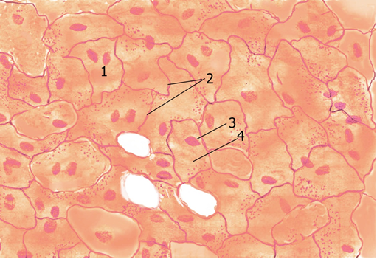

Fig. 4.1

Simple Squamous Epithelium Simple squamous epithelium is formed of a single layer of flat cells. Simple squamous epithelium (Fig. 4.1) is composed of a single layer of tightly packed, thin, or low-profile polygonal cells. When viewed from the surface, the epithelial sheet looks much like a tile floor with a centrally placed, bulging nucleus in each cell . Viewed in section, however, only some cells display nuclei, because the plane of section frequently does not encounter the nucleus. Simple squamous epithelia line pulmonary alveoli, compose the loop of Henle and the parietal layer of Bowman's capsule in the kidney, and form the endothelial lining of blood and lymph vessels as well as the mesothelium of the pleural and peritoneal cavities.
Simple Cuboidal Epithelium. Simple cuboidal epithelium is composed of a single layer of cells shaped like truncated hexagonal solids. A single layer of polygon-shaped cells constitutes simple cuboidal epithelium (Fig. 4.2) When viewed in a section cut perpendicular to the surface, the cells present a square profile with a centrally placed round nucleus. Simple cuboidal epithelia make up the ducts of many glands of the body, form the covering of the ovary, and compose some kidney tubules.

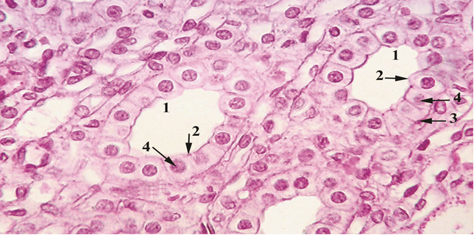

Fig. 4.2

Simple Columnar Epithelium. Simple columnar epithelium is composed of a single layer of tall cells shaped like hexagonal solids. The cells of simple columnar epithelium appear much like those of simple cuboidal epithelium in a surface view; when viewed in longitudinal section, however, they are tall, rectangular cells whose ovoid nuclei are usually located at the same level in the basal half of the cell. Simple columnar epithelium is found in the lining of much of the digestive tract, gallbladder, and large ducts of glands. Simple columnar epithelium may exhibit a striated border, or microvilli (narrow, finger-like cytoplasmic processes), projecting from the apical surface of the cells. The simple columnar epithelium that lines the uterus, oviducts, ductuli efferentes, and small bronchi is ciliated. In these organs, cilia (hair-like structures) project from the apical surface of the columnar cells into the lumen.
Stratified Squamous Epithelium Stratified squamous (nonkeratinized) epithelium comprises several layers of cells; the surface-most layer possesses nuclei. Stratified squamous (keratinized) epithelium is distinct in that the layers of cells composing the free surface are dead, non-nucleated, and filled with keratin. Nonkeratinized. Stratified squamous (nonkeratinized) epithelium (Fig. 4.5) is thick; because it is composed of several layers of cells, only the deepest layer is in contact with the basal lamina . The most basal (deepest) cells of this epithelium are cuboidal in shape; those located in the middle of the epithelium are polymorphous; and the cells composing the free surface of the epithelium are flattened (squamous)-hence the name stratified squamous. Because the surface cells are nucleated, this epithelium is called nonkeratinized. It is usually wet and is found lining the mouth, oral pharynx, esophagus, true vocal folds, and vagina. Keratinized. Stratified squamous keratinized epithelium (Fig. 4.6) is similar to stratified squamous nonkeratinized epithelium, except that the superficial layers of the epithelium are composed of dead cells whose nuclei and cytoplasm have been replaced with keratin. This epithelium constitutes the epidermis of skin, a tough layer that resists friction and is impermeable to water. Stratified Cuboidal Epithelium Stratified cuboidal epithelium, which contains only two layers of cuboidal cells, lines the ducts of the sweat glands. Stratified Columnar Epithelium. Stratified columnar epithelium comprises more than one layer of cells. The superficial layer is columnar in shape. Stratified columnar epithelium is composed of a low polyhedral to cuboidal deeper layer in contact with the basal lamina and a superficial layer of columnar cells. This epithelium is found only in a few places in the body-namely, the conjunctiva of the eye, certain large excretory ducts, and regions of the male urethra.
Transitional Epithelium. Transitional epithelium consists of several layers of cells. The surface layer is large and dome-shaped. Transitional epithelium (Fig. 4.7) received its name because it was erroneously believed to be in transition between stratified columnar and stratified squamous epithelia. This epithelium is now known to be a distinct type located exclusively in the urinary system, where it lines the urinary tract from the renal calyces to the urethra. Transitional epithelium is composed of many layers of cells; those located basally are either low columnar or cuboidal cells. Polyhedral cells compose several layers above the basal cells. The most superficial cells of the empty bladder are large, are occasionally binucleated, and exhibit rounded dome-shaped tops that bulge into the lumen. These dome-shaped cells become flattened and the epithelium becomes thinner when the bladder is distended.

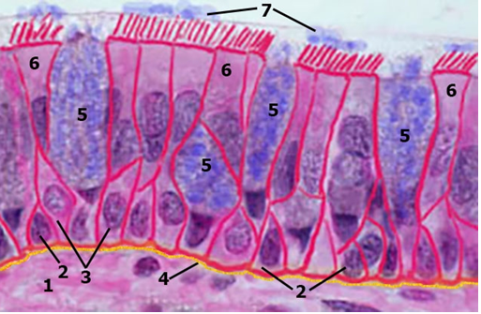

Fig. 4.3

Pseudostratified Columnar Epithelium. Pseudostratified columnar epithelium only appears stratified; all cells are in contact with the basal lamina (Fig. 4.3). As the name implies, pseudostratified columnar epithelium appears to be stratified but it is actually composed of a single layer of cells. All of the cells in pseudostratified columnar epithelium are in contact with the basal lamina, but only some cells reach the surface of the epithelium . Cells not extending to the surface usually have a broad base and become narrow at their apical end. Taller cells reach the surface and possess a narrow base in contact with the basal lamina and a broadened apical surface. Because the cells of this epithelium are of different heights, their nuclei are located at different levels, giving the impression of a stratified epithelium even though it is composed of a single layer of cells. Pseudostratified columnar epithelium is found in the male urethra, epididymis, and larger excretory ducts of glands. The most widespread type of pseudostratified columnar epithelium is ciliated, having cilia on the apical surface of the cells that reach the epithelial surface. Pseudostratified ciliated columnar epithelium is found lining most of the trachea and primary bronchi, the auditory tube, part of the tympanic cavity, the nasal cavity, and the lacrimal sac.
Polarity and Cell-Surface Specializations. Epithelial cell polarity and cell-surface specializations are related to cellular morphology and function. Most epithelial cells have distinct morphological, biochemical, and functional domains and thus commonly display a polarity that may be related to one or all of these differences. Such polarized cells, for instance, possess an apical domain that faces a lumen and a basolateral domain whose basal component is in contact with the basal lamina. Because these regions are distinct functionally, each may have surface modifications and specializations related to that function. For example, the apical surfaces of many epithelial cells possess microvilli or cilia, whereas their basolateral regions may exhibit many types of junctional specializations and intercellular interdigitations. The apical and basolateral domains are separated from each other by tight junctions that encircle the apical aspect of the cell.
Apical Domain. The apical domain represents the free surface of the epithelial cells. The apical domain, the region of the epithelial cell facing the lumen, is rich in ion channels, carrier proteins, H⁺-ATPase (adenosine triphosphatase), glycoproteins, and hydrolytic enzymes, as well as aquaporins, channel-forming proteins that function in regulation of water balance. It also is the site where regulated secretory products are delivered for release. Several surface modifications are necessary for the apical domain of an epithelium to carry out its many functions. These include microvilli with associated glycocalyx and, in some cases, stereocilia, cilia, and flagella.
Microvilli. Microvilli are small finger-like cytoplasmic projections emanating from the free surface of the cell into the lumen. When observed by electron microscopy, absorptive columnar (and cuboidal) epithelial cells exhibit closely packed microvilli, which are cylindrical, membrane-bound projections of the cytoplasm emanating from the apical (luminal) surface of these cells. Microvilli represent the striated border of the intestinal absorptive cells and the brush border of the kidney proximal tubule cells observed by light microscopy. In less active cells, microvilli may be sparse and short; in intestinal epithelia, whose major function is transport and absorption, they are crowded and 1 to 2 μm in length, thus greatly increasing the surface area of the cells. Each microvillus contains a core of 25 to 30 actin filaments, cross-linked by villin, attached to an amorphous region at its tip and extending into the cytoplasm, where the actin filaments are embedded in the terminal web. The terminal web is a complex of actin and spectrin molecules as well as intermediate filaments located at the cortex of the epithelial cells. At regular intervals, myosin-I and calmodulin connect the actin filaments to the plasma membrane of the microvillus, giving it support. Epithelia not functioning in absorption or transport may exhibit microvilli without cores of actin filaments. Light microscopy of epithelia stained for carbohydrates reveals the glycocalyx, evident in electron micrographs as an amorphous, fuzzy coating over the luminal surface of the microvilli. The glycocalyx represents carbohydrate residues attached to the transmembrane proteins of the plasmalemma. These glycoproteins function in protection and cell recognition.
Stereocilia (not be confused with cilia) are long microvilli found only in the epididymis and on the sensory hair cells of the cochlea (inner ear). It is believed that these nonmotile structures are unusually rigid because of their core of actin filaments. In the epididymis, they probably function in increasing the surface area; in the hair cells of the ear, they function in signal generation.
Cilia. Cilia are long, motile, hair-like structures emanating from the apical cell surface. Their core is composed of a complex arrangement of microtubules known as the axoneme. Cilia are motile, hair-like projections (diameter, 0.2 μm; length, 7 to 10 μm) that emanate from the surface of certain epithelial cells. In the ciliated epithelia of the respiratory system (e.g., trachea and bronchi) and in the oviduct, there may be hundreds of cilia in orderly arrays on the luminal surface of the cells. Other epithelial cells, such as the hair cells of the vestibular apparatus in the inner ear, possess only a single cilium, which functions in a sensory mechanism. Cilia are specialized to function in propelling mucus and other substances over the surface of the epithelium via rapid rhythmic oscillations. Cilia of the respiratory tree, for example, move mucus and debris toward the oropharynx, where it may be swallowed or expectorated. Cilia of the oviduct move the fertilized ovum toward the uterus. Electron microscopy reveals that cilia possess a specific internal structure that is consistently conserved throughout the plant and animal kingdoms. The core of the cilium contains a complex of uniformly arranged microtubules called the axoneme. The axoneme is composed of a constant number of longitudinal microtubules arranged in a consistent 9 + 2 organization . Two centrally placed microtubules (singlets) are evenly surrounded by nine doublets of microtubules. The two microtubules located in the center of the core are separated from each other, each displaying a circular profile in cross section, composed of 13 protofilaments. Each of the nine doublets is composed of two subunits. In cross section, subunit A is a microtubule composed of 13 protofilaments, exhibiting a circular profile. Subunit B possesses 10 protofilaments, exhibits an incomplete circular profile in cross section, and shares three protofilaments of subunit A. Several elastic protein complexes are associated with the axoneme.
Radial spokes project from subunit A of each doublet inward toward the central sheath surrounding the two singlets. Neighboring doublets are connected by nexin, another elastic protein, extending from subunit A of one doublet to subunit B of the adjacent doublet. The microtubule-associated protein dynein, also active in flagella, which has ATPase activity, radiates from subunit A of one doublet toward subunit B of the neighboring doublet. These dynein arms are arranged at 24-nm intervals along the length of subunit A. Dynein ATPase, by hydrolyzing ATP, provides the energy for the ciliary bending. Movement of the cilia is initiated by the dynein arms transiently attaching to specific sites on the protofilaments of the adjacent doublets, sliding them toward the tip of the cilium. However, nexin, an elastic protein extending between adjacent doublets, restrains this action to some degree, thus translating the sliding movement into a bending motion. As the cilium bends, an energy-requiring process, the elastic protein complex is stretched. When the dynein arms release their hold on the B subunit, the elastic protein complex returns to its original length, snapping the cilium back to its straight position (which does not require energy), effecting movement of material at the tip of the cilium. The 9 + 2 microtubule arrangement within the axoneme continues throughout most of the length of the cilium except at its base, where it is attached to the basal body . The morphology of the basal body is similar to that of a centriole, in that it is composed of nine triplets and no singlets. Basal bodies develop from procentriole organizers. As tubulin dimers are added, the procentriole lengthens to form the nine triplet microtubules characteristic of the basal body. After formation, the basal body migrates to the apical plasmalemma and gives rise to a cilium. Nine doublet microtubules develop from the nine triplets of the basal body, and a single pair of microtubules form to give the cilium its characteristic 9 + 2 microtubule arrangement.
Basolateral Domain. The basolateral domain includes the basal and lateral aspects of the cell membrane. The basolateral domain may be subdivided into two regions: the lateral plasma membrane and the basal plasma membrane. Each region possesses its own junctional specializations and receptors for hormones and neurotransmitters. In addition, these regions are rich in Na⁺,K⁺-ATPase and ion channels and are sites for constitutive secretion.
Lateral membrane specializations Lateral membrane specializations reveal the presence of junctional complexes.
Light microscopy reveals zones, called terminal bars, where epithelial cells are in contact and, presumably, attached to each other. Especially notable in the apical region of the simple columnar epithelium lining the gut, terminal bars were once thought to be composed of an amorphous intercellular cement substance. Horizontal sections through the terminal bars showed that they were continuous around the entire circumference of each cell, indicating that these cells were attached to every adjacent cell. Electron microscopy has revealed that terminal bars are in fact composed of intricate junctional complexes. These complexes, which hold contiguous epithelial cells together, may be classified into three types:

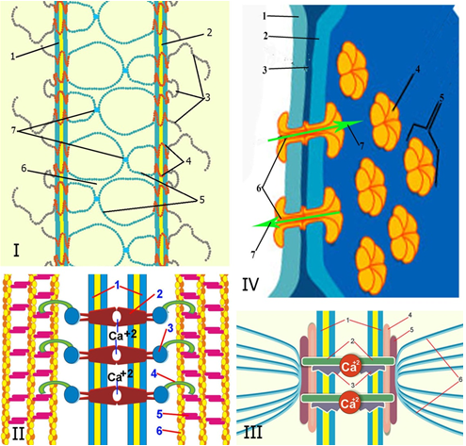

Fig. 4.4

- Occluding junctions (Fig. 4.4 I) function in joining cells to form an impermeable barrier, preventing material from taking an intercellular route in passing across the epithelial sheath.
- Anchoring junctions (Fig. 4.4 II, III) function in maintaining cell-to-cell or cell-to-basal lamina adherence.
- Communicating junctions (Fig. 4.4 IV) function in permitting movement of ions or signaling molecules between cells, thus coupling adjacent cells both electrically and metabolically.
The three components of the junctional complex are the zonulae occludentes, zonulae adherents, and desmosomes (maculae adherentes).
Zonulae Occludentes. Zonulae occludentes prevent movement of membrane proteins and function to prevent intercellular movement of water-soluble molecules. Also known as tight junctions (Fig. 4.4 I), zonulae occludentes are located between adjacent plasma membranes and are the most apically located junction between the cells of the epithelia . They form a "belt-like" junction that encircles the entire circumference of the cell. In electron micrographs, the adjoining cell membranes approximate each other; their outer leaflets fuse, then diverge, and then fuse again several times within a distance of 0.1 to 0.3 μm . At the fusion sites, transmembrane junctional proteins called claudins and occludins bind to each other, thus forming a seal occluding the intercellular space. Freeze-fracture analysis of cell membranes at the zonulae occludentes displays a "quilted" appearance of anastomosing strands, known as tight junction strands, on the P-face and a corresponding network of grooves on the E-face. Although both occludin and claudins participate in the formation of the tight junction, it appears that claudins have a more active role because these are the proteins that are probably responsible for the obliteration of the intercellular space by forming the tight junction strands described earlier. Not only are claudins calcium-independent, they do not form strong cell adhesions. As a result, their contact must be reinforced by cadherins as well as by cytoplasmic zonula occludens proteins such as ZO1, ZO2, and ZO3. Tight junctions function in two ways: (1) they prevent the movement of membrane proteins from the apical domain to the basolateral domain; (2) they fuse plasma membranes of adjacent cells to prohibit water-soluble molecules from passing between cells. Depending on the numbers and patterns of the strands in the zonula, some tight junctions are said to be "tight," whereas others are "leaky." These terms reflect the efficiency of the cells in maintaining the integrity of the epithelial barrier between two adjacent body compartments.
Zonulae Adherentes Zonulae adherentes are belt-like junctions that assist adjoining cells to adhere to one another. Zonulae adherentes (Fig. 4.4 II) of the junctional complex are located just basal to the zonulae occludentes and also encircle the cell . The intercellular space of 15 to 20 nm between the outer leaflets of the two adjacent cell membranes is occupied by the extracellular moieties of cadherins. These Ca²⁺-dependent integral proteins of the cell membrane are transmembrane linker proteins. Their intracytoplasmic aspect binds to a specialized region of the cell web, specifically a bundle of actin filaments that run parallel to and along the cytoplasmic aspect of the cell membrane. The actin filaments are attached to each other and to the cell membrane by the anchor proteins catenin, vinculin, and α-actinin . The extracellular region of the cadherins of one cell forms bonds with those of the adjoining cell participating in the formation of the zonula adherens. Thus, this junction not only joins the cell membranes to each other but also links the cytoskeleton of the two cells via the transmembrane linker proteins.
Fascia adherens is similar to zonula adherens but does not go around the entire circumference of the cell. Instead of being belt-like, it is "ribbon-like." Cardiac muscle cells, for example, are attached to each other at their longitudinal terminals via the fascia adherens.
Desmosomes (Maculae Adherentes) Desmosomes are weld-like junctions along the lateral cell membranes that help to resist shearing forces. Desmosomes (Fig. 4.4 III) are the last of the three components of the junctional complex. These "spot weld"-like junctions also appear to be randomly distributed along the lateral cell membranes of simple epithelia and throughout the cell membranes of stratified squamous epithelia, especially in the epidermis. Disk-shaped attachment plaques (∼400 × 250 × 10 nm) are located opposite each other on the cytoplasmic aspects of the plasma membranes of adjacent epithelial cells. Each plaque is composed of a series of attachment proteins, the best characterized of which are desmoplakins and pakoglobins. Intermediate filaments of cytokeratin are observed to insert into the plaque, where they make a hairpin turn, then extend back out into the cytoplasm. These filaments are thought to be responsible for dispersing the shearing forces on the cell. In the region of the opposing attachment plaques, the intercellular space is up to 30 nm in width and contains filamentous materials with a thin, dense, vertical line located in the middle of the intercellular space. High-resolution electron microscopy reveals that the filamentous material is desmoglein and desmocollin, extracellular components of the Ca²⁺-dependent transmembrane linker proteins of the cadherin family. In the presence of Ca²⁺, they bond with transmembrane linker proteins from the adjoining cell. In the presence of a calcium-chelating agent, the desmosomes break into two halves and the cells separate. Thus, two cells are required for the formation of a desmosome. The cytoplasmic aspects of the transmembrane linker proteins bind to the desmoplakins and pakoglobins constituting the plaque.
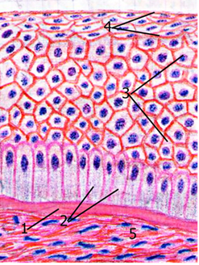
Fig. 4.5
Gap Junctions. Gap junctions, also called nexus or communicating junctions, are regions of intercellular communication. Gap junctions (Fig. 4.4 IV) are widespread in epithelial tissues throughout the body as well as in cardiac muscle cells, smooth muscle cells, and neurons, but not in skeletal muscle cells. They differ from the occluding and anchoring junctions in that they mediate intercellular communication by permitting the passage of various small molecules between adjacent cells. The intercellular cleft at the gap junction is narrow and constant, about 2 to 4 nm. Gap junctions are built by six closely packed transmembrane channel-forming proteins (connexins) that assemble to form channel-structures called connexons, aqueous pores through the plasma membrane that juts out about 1.5 nm into the intercellular space . Presently it is believed that there may be more than 20 different connexins which can assemble into many different arrays of connexons that may be related to their specific function. Each gap junction may be formed by clusters of a few to many thousands of connexons. When a connexon of one plasma membrane is in register with its counterpart of the adjacent plasma membrane, the two connexons fuse, forming a functional intercellular hydrophilic communication channel . With a diameter of 1.5 to 2.0 nm, the hydrophilic channel permits the passage of ions, amino acids, vitamins, cyclic adenosine monophosphate (cAMP), certain hormones, and molecules smaller than 1 kDa in size. Gap junctions are regulated, and may be opened or closed rapidly. Although the opening and closing mechanism is not fully understood, it has been shown experimentally that a decrease in cytosolic pH or an increase in cytosolic Ca²⁺ concentrations closes gap junctions. Conversely, high pH or low Ca²⁺ concentrations opens the channels. In addition, gap junctions exhibit different properties with diverse channel permeabilities in different cells. Gap junctions exhibit many diverse functions within the body, including cellular sharing of molecules for coordinating physiological continuity within a particular tissue. For example, when glucose is needed in the bloodstream, the nervous system stimulates liver cells (hepatocytes) to initiate glycogen breakdown. Because not all hepatocytes are individually stimulated, the signal is dispersed to other hepatocytes via gap junctions, thus coupling the hepatocytes. Gap junctions also function in electrical coupling of cells (i.e., in heart muscle and in smooth muscle cells of the gut during peristalsis), thus coordinating the activities of these cells. Gap junctions also are important during embryogenesis in coupling the cells of the developing embryo electrically and in distributing informational molecules throughout the migrating cell masses, thus keeping them coordinated in the proper development pathway.

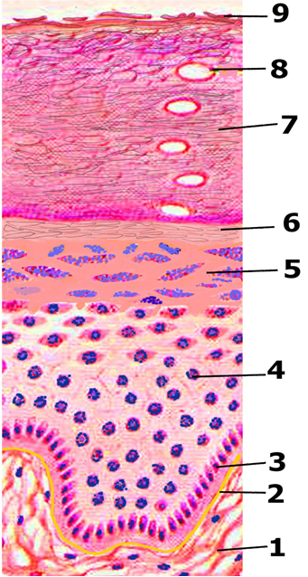

Fig. 4.6

Basal surface specializations. Basal surface specializations include the basal lamina, plasma membrane enfoldings, and hemidesmosomes. Three important features mark the basal surface of epithelia: the basal lamina, plasma membrane enfoldings, and hemidesmosomes, which anchor the basal plasma membrane to the basal lamina. The basal lamina is an extracellular supporting structure secreted by an epithelium and is located at the boundary between the epithelium and the underlying connective tissue.
Plasma Membrane Enfoldings. Enfoldings of the basal plasma membrane increase the surface area available for transport. The basal surface of some epithelia, especially those involved in ion transport, possesses multiple finger-like enfoldings of the basal plasma membranes that increase the surface area of the plasmalemma and partition the mitochondria-rich basal cytoplasm. The mitochondria provide the energy required for active transport of ions in establishing osmotic gradients to ensure the movement of water across the epithelium, such as those of the kidney tubules. The compactness of the enfolded plasma membranes coupled with the arrangement of the mitochondria within the enfoldings gives a striated appearance when viewed with the light microscope; this is the origin of the term striated ducts describing certain ducts of the pancreas and salivary glands.
Hemidesmosomes. Hemidesmosomes attach the basal cell membrane to the underlying basal lamina. Hemidesmosomes resemble half desmosomes and serve to attach the basal cell membrane to the basal lamina . Attachment plaques, composed of desmoplakins, plectin, and other associated proteins, are present on the cytoplasmic aspect of the plasma membrane. Keratin tonofilaments insert into these plaques, unlike those in the desmosome, where the filaments enter the plaque and then make a sharp turn to exit it. The cytoplasmic aspects of transmembrane linker proteins are attached to the plaque, whereas their extracellular moieties bind to laminin and type IV collagen of the basal lamina. The transmembrane linker proteins of hemidesmosomes are integrins, a family of extracellular matrix receptors, whereas those of desmosomes belong to the cadherin family of cell-to-cell adhesion proteins.

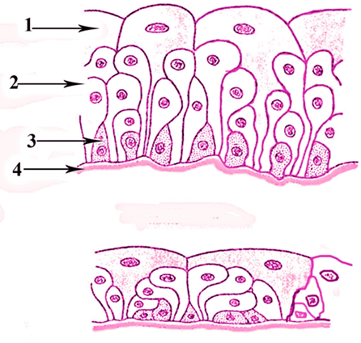

Fig. 4.7

Renewal of Epithelial Cells Cells making up the epithelial tissues generally exhibit a high turnover rate, which is related to their location and function. The time frame for cell renewal remains constant for a particular epithelium. Cells of the epidermis, for example, are constantly being renewed at the basal layer by cell division. From here the cells begin their migration from the germinal layer to the surface, being keratinized on their route until they reach the surface, die, and are sloughed-the total event taking approximately 28 days. Other epithelial cells are renewed in less time.

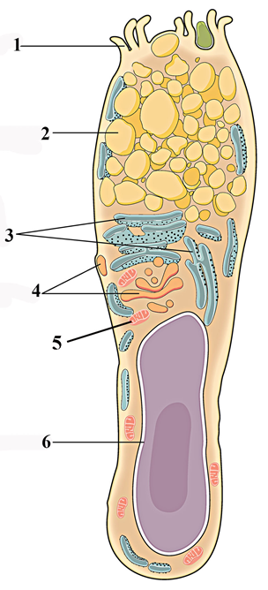

Fig. 4.8

Glands originate from epithelial cells that leave the surface where they developed and penetrate into the underlying connective tissue, manufacturing a basal lamina around themselves. The secretory units, along with their ducts, are the parenchyma of the gland, whereas the stroma of the gland represents the elements of the connective tissue that invade and support the parenchyma. Glandular epithelia manufacture their product intracellularly by synthesis of macromolecules that are usually packaged and stored in vesicles called secretory granules. The secretory product may be a polypeptide hormone (e.g., from the pituitary gland); a waxy substance (e.g., from the ceruminous glands of the ear canal); a mucinogen (e.g., from the goblet cells); or milk, a combination of protein, lipid, and carbohydrates (e.g., from the mammary glands). Other glands (such as sweat glands) secrete little besides the exudate they receive from the bloodstream. In addition, striated ducts (e.g., those of the major salivary glands) act as ion pumps that modify the substances produced by their secretory units. Glands are classified into two major groups on the basis of the method of distribution of their secretory products:
- Exocrine glands secrete their products via ducts onto the external or internal epithelial surface from which they originated.
- Endocrine glands are ductless, having lost their connections to the originating epithelium, and thus secrete their products into the blood or lymphatic vessels for distribution.
Many cell types secrete signaling molecules called cytokines, which perform the function of cell-to-cell communication. Cytokines are released by signaling cells and act on target cells, which possess receptors for the specific signaling molecule. Depending on the distance the cytokine must travel to reach its target cell, its effect may be one of the following:
- Autocrine: The signaling cell is its own target; thus the cell stimulates itself.
- Paracrine: The target cell is located in the vicinity of the signaling cell; thus, the cytokine does not have to enter the vascular system for distribution to its target.
- Endocrine: The target cell and signaling cell are far from each other; thus, the cytokine has to be transported either by the blood or by the lymph vascular system.

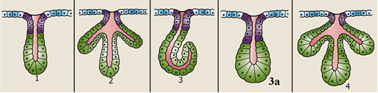

Fig. 4.9

Glands that secrete their products via a constitutive secretory pathway do so continuously, releasing their secretory products immediately without storage and without requiring a prompt by signaling molecules. Glands that exhibit a regulated secretory pathway concentrate and store their secretory products until the proper signaling molecule for its release is received
Exocrine Glands. Exocrine glands secrete their products via a duct to the surface of their epithelial origin. Exocrine glands (Fig. 4.10) are classified according to the nature of their secretion, their mode of secretion, and the number of cells (unicellular or multicellular). Many exocrine glands in the digestive, respiratory, and urogenital systems secrete substances that are described as mucous, serous, or mixed (both) types.

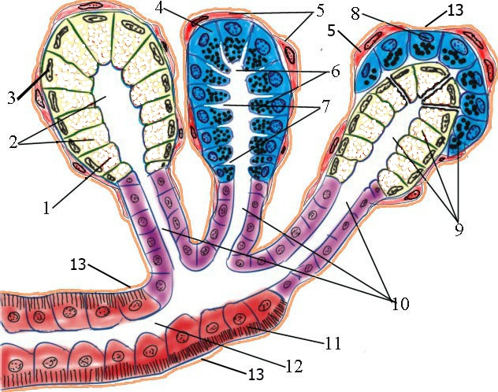

Fig. 4.10

Mucous glands secrete mucinogens, large glycosylated proteins that, upon hydration, swell to become a thick, viscous, gel-like protective lubricant known as mucin, a major component of mucus. Examples of mucous glands include goblet cells and the minor salivary glands of the tongue and palate.
Serous glands such as the pancreas, secrete an enzyme-rich watery fluid.
Mixed glands contain acini (secretory units) that produce mucous secretions as well as acini that produce serous secretions; in addition, some of the mucous acini possess serous demilunes, a group of cells that secrete a serous fluid. The sublingual and submandibular glands are examples of mixed glands. Cells of exocrine glands exhibit three different mechanisms for releasing their secretory products: (1) holocrine, (2) merocrine, and (3) apocrine (Fig. 4.11).

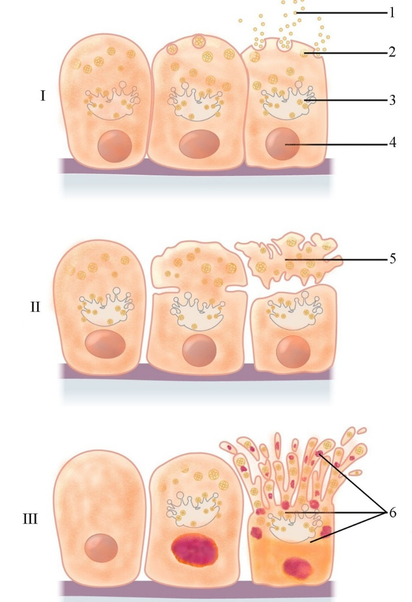

Fig. 4.11

The release of the secretory product of merocrine glands (e.g., parotid gland) occurs via exocytosis; as a result, neither cell membrane nor cytoplasm becomes a part of the secretion. Although many investigators question the existence of the apocrine mode of secretion, historically it was believed that in apocrine glands (e.g., lactating mammary gland), a small portion of the apical cytoplasm is released along with the secretory product. In holocrine glands (e.g., sebaceous gland), as a secretory cell matures, it dies and becomes the secretory product.
Unicellular Exocrine Glands. Unicellular exocrine glands are the simplest form of exocrine gland. Unicellular exocrine glands , represented by isolated secretory cells in an epithelium, are the simplest form of exocrine gland. A primary example is the goblet cell (Fig. 4.8), which is dispersed individually in the epithelia lining the digestive tract and portions of the respiratory tract . The secretions released by these mucous glands protect the linings of these tracts. Goblet cells derive their name from their shape, that of a goblet . Their thin basal region sits on the basal lamina, whereas their expanded apical portion, the theca, faces the lumen of the digestive tube or respiratory tract. The theca is filled with membrane-bound secretory droplets, which displace the cytoplasm to the cell's periphery and the nucleus toward its base. The process of mucinogen release is regulated and stimulated by chemical irritation and parasympathetic innervation, resulting in exocytosis of the entire secretory contents of the cell, thus lubricating and protecting the epithelial sheet.
Multicellular Exocrine Glands. Multicellular exocrine glands exist as organized clusters of secretory units. Multicellular exocrine glands consist of clusters of secretory cells arranged in varying degrees of organization. These secretory cells do not act alone and independently but instead function as secretory organs. Multicellular glands may have a simple structure, exemplified by the glandular epithelium of the uterus and gastric mucosa, or a complex structure, composed of various types of secretory units and organized in a compound branching fashion. Because of their structural arrangement, multicellular glands are subclassified according to the organization of their secretory and duct components as well as according to the shape of their secretory units. Multicellular glands are classified as simple (Fig. 4.9) if their ducts do not branch and compound (Fig. 4.12) if their ducts branch. They are further categorized according to the morphology of their secretory units as tubular, acinar (also referred to as alveolar, resembling a grape), or tubuloalveolar. Larger multicellular glands are surrounded by a collagenous connective tissue capsule, which sends septae (strands of connective tissue) into the gland, subdividing it into smaller compartments known as lobes and lobules. Vascular elements, nerves, and ducts utilize the connective tissue septa to enter and exit the gland. In addition, the connective tissue elements provide structural support for the gland. Acini of many multicellular exocrine glands such as sweat glands and major salivary glands possess myoepithelial cells that share the basal lamina of the acinar cells. Although myoepithelial cells are of epithelial origin, they have some characteristics of smooth muscle cells, particularly contractility. These cells exhibit small nuclei and sparse fibrillar cytoplasm radiating out from the cell body, wrapping around the acini and some of the small ducts . Their contractions assist in expressing secretions from the acini and from some small ducts.

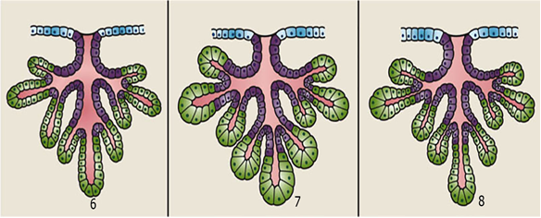

Fig. 4.12

